**Design Thinking Project Workbook**

**Don't find customers for your product but find products for your customers**

**Team 20**

**Team Name: Munch Muse**

**Team Logo :**



**Team Members:**

1. Angelina, 2320030428
2. Varshitha, 2320030223

**2. Problem/Opportunity Domain**

**Domain of Interest: Food and Meal planning**

**Description of the Domain: The domain of recipe recommendation and meal planning is about helping individuals or families make informed choices about their meals. Key elements include:**

**User Preferences: Understanding dietary restrictions, cuisine preferences, and nutritional needs.**

**Ingredient Availability: Utilizing ingredients users already have at home to minimize waste and save money.**

**Health and Wellness: Providing recipes that cater to specific health goals, such as weight loss, muscle gain, or managing chronic conditions.**

**Cultural Diversity: Offering a variety of recipes from different cultures to cater to a global audience.**

**Challenges:**

**Personalization: Creating a system that accurately reflects individual tastes and dietary needs.**

**Data Integration: Accessing and integrating data from various recipe sources and nutritional databases.**

**User Engagement: Keeping users engaged and motivated to try new recipes and meal plans.**

**Opportunities:**

**Growing Demand: Increasing interest in healthy eating and meal prep solutions.**

**Technological Advancements: Leveraging AI and machine learning to enhance user experience and recommendations.**

**Partnerships: Collaborating with grocery delivery services or food brands for seamless ingredient sourcing.**

**Why did you choose this domain?: The personal or strategic reasons for selecting this domain, such as passion, market potential, or solving a specific problem.**

**3. Problem/Opportunity Statement**

**Problem Statement: A clear and specific articulation of the problem, outlining its importance.**

**Problem Description: A concise explanation of the issue or challenge that needs to be solved.**

**Context (When does the problem occur): The specific situations or conditions under which the problem arises.**

**Alternatives (What does the customer do to fix the problem): Existing solutions or actions taken by customers to address the issue.**

**Customers (Who has the problem most often): The primary group of individuals or organizations affected by the problem.**

**Emotional Impact (How does the customer feel): The emotions or frustrations experienced by the customer due to the problem.**

**Quantifiable Impact (What is the measurable impact): The measurable effects of the problem, such as financial losses or time wasted.**

**Alternative Shortcomings (What are the disadvantages of the alternatives): The limitations or downsides of the current solutions customers use.**

**Any Video or Images to showcase the problem: The evidence in the form of video or image).**

**Provide link if available**

**3. Addressing SDGs**

**Relevant Sustainable Development Goals (SDGs): Identify which of the 17 SDGs are directly impacted by the problem or opportunity.**

**How does your problem/opportunity address these SDGs?: Describe how solving the problem or leveraging the opportunity will contribute to achieving one or more SDGs.**

**4. Stakeholders**

Answer these below questions to understand the stakeholder related to your project

1. **Who are the key stakeholders involved in or affected by this project?**
2. **What roles do the stakeholders play in the success of the innovation?**
3. **What are the main interests and concerns of each stakeholder?**
4. **How much influence does each stakeholder have on the outcome of the project?**
5. **What is the level of engagement or support expected from each stakeholder?**
6. **Are there any conflicts of interest between stakeholders? If so, how can they be addressed?**
7. **How will you communicate and collaborate with stakeholders throughout the project?**
8. **What potential risks do stakeholders bring to the project, and how can these be mitigated?**

**5. Power Interest Matrix of Stakeholders**

**Power Interest Matrix: Provide a diagrammatic representation of Power Interest Matrix**

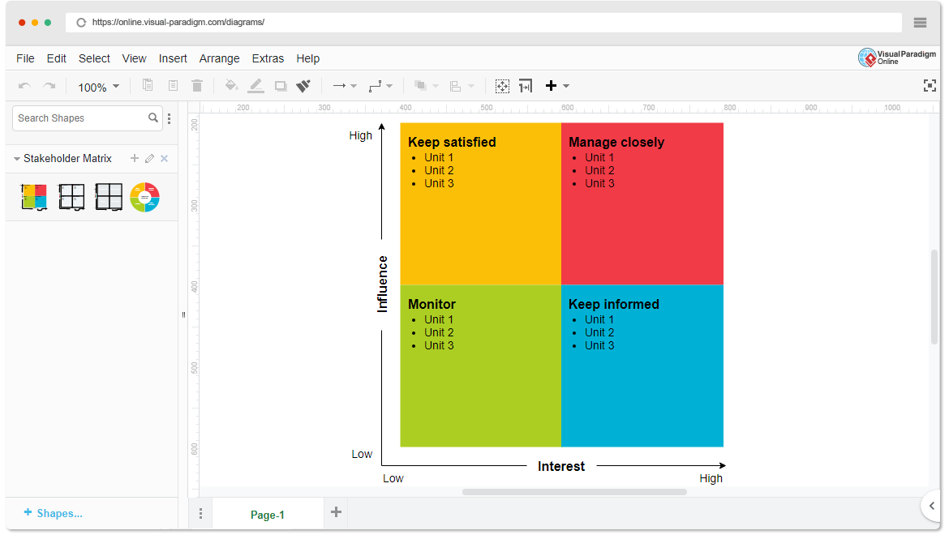

* High Power, High Interest: [Stakeholder Names]
* High Power, Low Interest: [Stakeholder Names]
* Low Power, High Interest: [Stakeholder Names]
* Low Power, Low Interest: [Stakeholder Names]

1. **Empathetic Interviews**

**Conduct Skilled interview with at least 30 citizens/Users by asking open ended questions (What, why/How etc) and list the insights as per the format below**

|  |  |  |
| --- | --- | --- |
| **I need to know**  **(thoughts, feelings, actions)** | **Questions I will ask**  **(open questions)** | **Insights I hope to gain** |
| Thoughts |  |  |
|  |  |  |
|  |  |  |
| Feelings |  |  |
|  |  |  |
|  |  |  |
| actions |  |  |
|  |  |  |
|  |  |  |

**SKILLED INTERVIEW REPORT**

**(Examples are given. Erase them and fill with your user information.)**

|  |  |  |
| --- | --- | --- |
| **User/Interviewee** | **Questions Asked** | **Insights gained (NOT THEIR ANSWERS)** |
| Abhishek Verma,  Student | Which party do you vote for? | Citizens are not very open about their political preferences |
| Srinivasan P., Parent | How do you feel about the plans for a new capital? | Some citizens are sad that the capital is being relocated from Hyderabad. |
|  |  |  |
|  |  |  |
|  |  |  |

**Key Insights Gained:**

* **Insight 1**
* **Insight 2**

**Empathy Map**

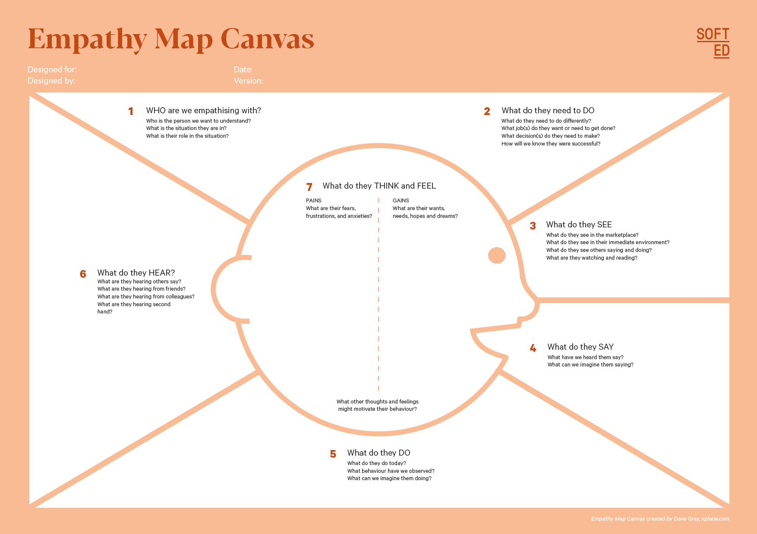

Your Answer:

Your Answer:

Who is your Customer Segment:

Idea/Innovation Title:

Designed By:

Date of Submission:

Your Answer:

Your Answer:

Your Answer:

Your Answer:

Your Answer:

Your Answer:

Your Answer:

1. **Empathy Map**
2. **Who is your Customer?**

**Description: This is where you specify the customer or user you are empathizing with. It could be a specific user persona or a general user segment.**

**Key points:**

* **Define the customer profile clearly (e.g., age, profession, interests).**
* **State their goals and needs related to the innovation or product.**
* **Context in which the user will interact with your solution.**

1. **Who are we empathizing with?**

**Description: This area helps you define who the user is, what their situation looks like, and what role they play. It emphasizes understanding the user’s perspective in depth.**

**Key points:**

* **Define the user's characteristics (e.g., personality, values, and responsibilities).**
* **State the user's goals and challenges in their environment.**
* **What is the user's broader situation (professionally or personally)?**

1. **What do they need to DO?**

**Description: This section identifies what actions or tasks the user needs to perform. It helps highlight the expectations and demands the user faces.**

**Key points:**

* **Clarify the tasks or actions the user needs to complete.**
* **What decisions do they need to make?**
* **How do they define success or failure in their tasks?**

1. **What do they SEE?**

**Description: This focuses on the visual stimuli or environment that the user interacts with. It's important to consider what users see in their immediate surroundings and in their larger world.**

**Key points:**

* **What do users see in their physical and digital environment?**
* **What trends or competitors do they notice?**
* **How do these visual elements influence their behavior?**

1. **What do they SAY?**

**Description: This section captures what the user might say in public, such as comments or feedback they give in conversations or on social media.**

**Key points:**

* **What might users express openly in conversation about their problems?**
* **How do they express their goals or frustrations?**
* **What are their words during customer interviews or feedback?**

1. **What do they DO?**

**Description: This section focuses on what the user does, the actual behaviors they exhibit, and actions they take in different situations.**

**Key points:**

* **What observable actions do users take?**
* **What habits or routines do they follow?**
* **What might users do to try and solve their problems?**

1. **What do they HEAR?**

**Description: This addresses what information the user receives from external sources, such as colleagues, media, or industry trends. It helps map the influences surrounding the user.**

**Key points:**

* **What are they hearing from peers, mentors, or the industry?**
* **What media or channels of information are they exposed to?**
* **Are there any strong influencers guiding their behavior?**

1. **What do they THINK and FEEL?**

**Description: This is one of the most insightful sections, addressing the internal emotions, concerns, and motivations of the user. It helps identify their deep-rooted feelings.**

**Key points:**

* **What are their fears, worries, and anxieties?**
* **What are their motivations and desires?**
* **How do their thoughts and feelings align with their actions?**

1. **Pains and Gains**

**Description: This section focuses on the user’s frustrations and their desired outcomes. It helps to frame the user’s challenges (pains) and the benefits they seek (gains).**

**Key points:**

* **What are the user’s main pain points?**
* **What would make their life easier or more fulfilling?**
* **What benefits do they hope to achieve from your product or solution?**

**8. Persona of Stakeholders**

**Stakeholder Name:**

**Demographics: Key characteristics of your target audience, such as age, gender, income, and location.**

**Goals: What the stakeholders or customers want to achieve in relation to the innovation.**

**Challenges: The obstacles or difficulties faced by stakeholders that the innovation aims to address.**

**Aspiration: The long-term desires or dreams of your target audience related to the innovation.**

**Needs: The essential requirements of your customers or stakeholders that must be met.**

**Pain Points: Specific problems or frustrations experienced by the target audience.**

**Storytelling: A narrative that highlights the journey of the stakeholder or customer, illustrating the problem and how the innovation can solve it.**

**Sample:**

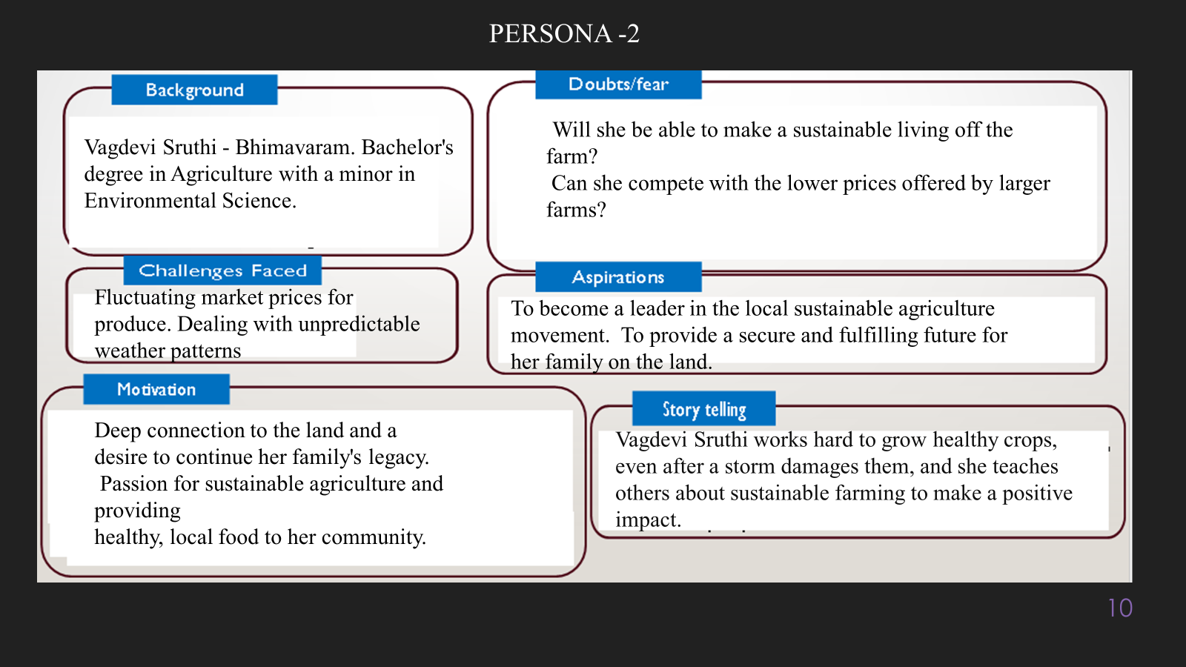

**10. Look for Common Themes, Behaviors, Needs, and Pain Points among the Users**

Analyse the data from your affinity diagram to uncover recurring patterns among your users, helping you better understand their expectations and challenges.

**Common Themes: Identify broad ideas or issues that repeatedly appear across different groups in your affinity diagram.**

**Common Behaviors: Observe how users consistently act or respond in relation to the problem or product throughout their journey.**

**Common Needs: Pinpoint essential requirements or desires that many users share, highlighting what they need for a better experience.**

**Common Pain Points: Look for frustrations or obstacles that frequently hinder the user experience, which your project can address.**

**12. Define Needs and Insights of Your Users**

**User Needs: Define the core requirements your users have in relation to the problem or product. These could be functional, emotional, or societal needs that your solution must address.**

**User Insights: Summarize the key understandings or observations you've uncovered about your users' behaviors, motivations, and pain points. These insights provide a deeper understanding of why users behave the way they do and what drives their decisions.**

**13. POV Statements**

**POV Statements:**

* [User] needs a way to [need] because [insight].

|  |  |  |  |
| --- | --- | --- | --- |
| PoV Statements  (At least ten) | Role-based or Situation-Based | Benefit, Way to Benefit,  Job TBD,  Need (more/less) | PoV Questions  (At least one per statement) |
| (Erase this example) When I drive to work, I want to avoid traffic jams so I don’t get in trouble with my boss for being late. | Situation | Way to Benefit | What can we design that will enable drivers to avoid traffic jams?  What can we design that will enable workers to avoid getting in trouble for being late to work? |
|  |  |  |  |
|  |  |  |  |
|  |  |  |  |
|  |  |  |  |

**14. Develop POV/How Might We (HMW) Questions to Transform Insights/Needs into Opportunities for Design**

Turn your user needs and insights into actionable opportunities by framing them as "How Might We" (HMW) questions. These questions will spark creative problem-solving and guide your innovation process.

1. **How Might We: Based on the needs and insights you've identified, create open-ended questions starting with "How might we...?" These questions should aim to solve user pain points, enhance the experience, or address specific needs.**

**Examples:**

* **User Need: "Users need a quicker way to access customer support."**
  + **HMW Question: "How might we create a more efficient and accessible customer support system?"**
* **Insight: "Users feel overwhelmed by too many options."**
  + **HMW Question: "How might we simplify decision-making for our users?"**

**Task:**

**Write 3-5 "How Might We" questions based on your analysis of user needs and insights. These questions should challenge you to think of innovative solutions that can address user problems in meaningful ways.**

**This task encourages participants to think creatively about solving user problems, transforming challenges into opportunities for innovation.**

|  |  |
| --- | --- |
| User Need/Insight | "How Might We" Question |
| [State the user need or insight clearly] | **How might we... [formulate an open-ended question to address the need or insight]?** |

**16. Crafting a Balanced and Actionable Design Challenge**

The Design Challenge Should Neither Be Too Narrow Nor Too Broad and It Should Be an Actionable Statement with a quantifiable goal. It should be a culmination of the POV questions developed.

**Design Challenge:** [Actionable Statement]

**17. Validating the Problem Statement with Stakeholders for Alignment**

Ensure your problem statement accurately represents the needs and concerns of your stakeholders and users. This involves gathering feedback from these groups to confirm that the problem is relevant and significant from their perspective. By validating early, you can refine the problem statement to better align with real-world challenges, ensuring your solution addresses the correct issues.

**Validation Plan:**

**Stakeholder/User Feedback (Min. 10 Stakeholders/Experts):**

|  |  |  |  |
| --- | --- | --- | --- |
| Stakeholder/User | Role | Feedback on Problem Statement | Suggestions for Improvement |
| [Name/Group] | **[Role/Title]** | **[Does the problem resonate with them? Why or why not?]** | **[Suggestions for refining the problem statement]** |
| [Name/Group] | **[Role/Title]** | **[Does the problem resonate with them? Why or why not?]** | **[Suggestions for refining the problem statement]** |

**18. Ideation**

**Ideation Process:**

|  |  |  |  |
| --- | --- | --- | --- |
| Idea Number | Proposed Solution | Key Features/Benefits | Challenges/Concerns |
| Idea 1 | **[Brief description of solution]** | **[What are the key benefits of this solution?]** | **[What challenges or concerns exist?]** |
| Idea 2 | **[Brief description of solution]** | **[What are the key benefits of this solution?]** | **[What challenges or concerns exist?]** |
| Idea 3 | **[Brief description of solution]** | **[What are the key benefits of this solution?]** | **[What challenges or concerns exist?]** |
| Idea 4 | **[Brief description of solution]** | **[What are the key benefits of this solution?]** | **[What challenges or concerns exist?]** |
| Idea 5 | **[Brief description of solution]** | **[What are the key benefits of this solution?]** | **[What challenges or concerns exist?]** |

**18. Idea Evaluation**

Evaluate the Idea based on 10/100/1000 grams

|  |  |  |  |  |
| --- | --- | --- | --- | --- |
| Idea | Impact (10/100/1000 grams) | Feasibility (10/100/1000 grams) | Alignment (10/100/1000 grams) | Total Weight |
| Idea 1 | **[Assign weight]** | **[Assign weight]** | **[Assign weight]** | **[Sum of weights]** |
| Idea 2 | **[Assign weight]** | **[Assign weight]** | **[Assign weight]** | **[Sum of weights]** |
| Idea 3 | **[Assign weight]** | **[Assign weight]** | **[Assign weight]** | **[Sum of weights]** |
| Idea 4 | **[Assign weight]** | **[Assign weight]** | **[Assign weight]** | **[Sum of weights]** |
| Idea 5 | **[Assign weight]** | **[Assign weight]** | **[Assign weight]** | **[Sum of weights]** |

**Example:**

|  |  |  |  |  |
| --- | --- | --- | --- | --- |
| Idea | Impact (10/100/1000 grams) | Feasibility (10/100/1000 grams) | Alignment (10/100/1000 grams) | Total Weight |
| Idea 1 | **1000** | **100** | **1000** | **2100** |
| Idea 2 | **100** | **1000** | **100** | **1200** |
| Idea 3 | **100** | **100** | **100** | **300** |

Further, use solution concept form to scrutinize the idea

**Solution Concept Form**

**1. Problem Statement:**

* **[State the validated problem your solution addresses.]**

**2. Target Audience:**

* **[Describe the main users or customers who will benefit from this solution.]**

**3. Solution Overview:**

* **[Provide a brief description of the solution concept.]**

**4. Key Features:**

| **Feature** | **Description** |
| --- | --- |
| **Feature 1** | **[Briefly describe the main feature of your solution]** |
| **Feature 2** | **[Briefly describe another key feature]** |
| **Feature 3** | **[Briefly describe a third key feature]** |

**5. Benefits:**

| **Benefit** | **Description** |
| --- | --- |
| **Benefit 1** | **[What value does this solution bring?]** |
| **Benefit 2** | **[How does this solution solve the problem?]** |
| **Benefit 3** | **[What makes this solution stand out?]** |

**6. Unique Value Proposition (UVP):**

* **[Summarize why this solution is unique and why it will appeal to your target audience.]**

**7. Key Metrics:**

| **Metric** | **Measurement** |
| --- | --- |
| **Metric 1** | **[What is the key metric to measure success?]** |
| **Metric 2** | **[What is another key metric for tracking progress?]** |

**8. Feasibility Assessment:**

* **[Provide a brief evaluation of how achievable or practical this solution is (consider resources, time, and technology).]**

**9. Next Steps:**

* **[Outline the next steps for further developing or prototyping this solution.]**